## horizontal line



Statistical Analysis

2/5/2019

**Instructor name : Dr Mahmoud Mounir**

**Team members:**

1. **Afnan Amin (sec 4)**
2. **Aya El Moaz Ballah (sec 4)**
3. **Asmaa Ali Hassan(sec 4)**
4. **Amany Ali Fekry(sec 5)**
5. **Tasneem AbdelMoaen Safoor(sec 5)**

# Overview

**Say, a teacher wants to know if there is a difference between the academic performance of pupils who have had early exposure in Mathematics and pupils without such exposure. Academic performance is still a broad measure, so let’s make it more specific. We’ll take summative test score in Mathematics as the** [**variable**](https://simplyeducate.me/2012/10/22/what-are-examples-of-variables-in-research/) **in focus.**

**To test for difference in performance, that is, after random selection of students with about equal aptitudes, the same grade level, the same Math teacher, among others**

**1-Is there a significant difference between the Mathematics test score of pupils who have had early Mathematics exposure and those pupils without?**

# Goals

1. Practical application of Statistics Analysis ( Calculating central tendency using various methods , Calculating inference and applying Estimation methods, Calculating Correlations using Person’s R method)
2. Learn to use Python and Graphical User Interface using Pycharm
3. Learning to write Analytical Reports
4. Learn to analyze Data Graphically

# Specifications

So how to compare between these 2 samples , we can use **Z -score Method**

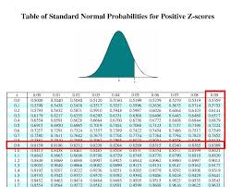

**Z-scores are a way to compare results from a test to a “normal” population. Results from tests or surveys have thousands of possible results and units.**

Or we can explain it graphically by using so many means , like using **Pie Chart**

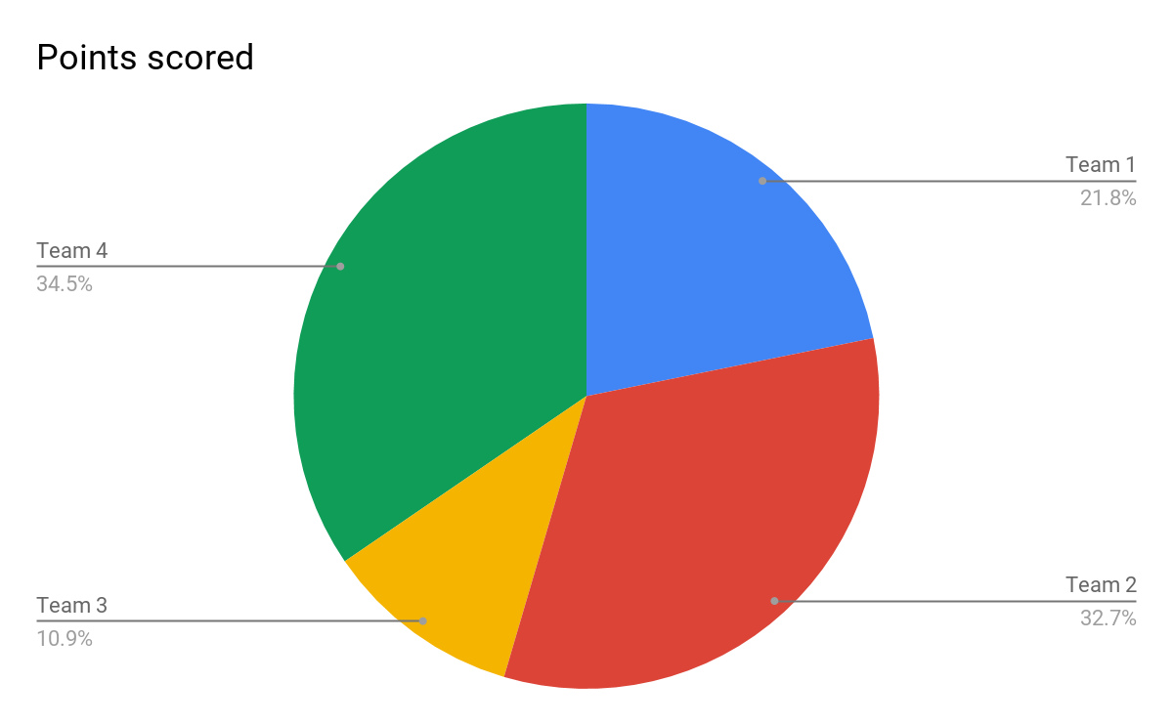

**A pie chart (or a circle chart) is a circular** [**statistical graphic**](https://en.wikipedia.org/wiki/Statistical_graphics)**, which is divided into slices to illustrate numerical proportion. In a pie chart, the** [**arc length**](https://en.wikipedia.org/wiki/Arc_length) **of each slice (and consequently its** [**central angle**](https://en.wikipedia.org/wiki/Central_angle) **and** [**area**](https://en.wikipedia.org/wiki/Area)**), is** [**proportional**](https://en.wikipedia.org/wiki/Proportionality_(mathematics)) **to the quantity it represents. While it is named for its resemblance to a** [**pie**](https://en.wikipedia.org/wiki/Pie) **which has been sliced**

Or by using **Bar Chart**

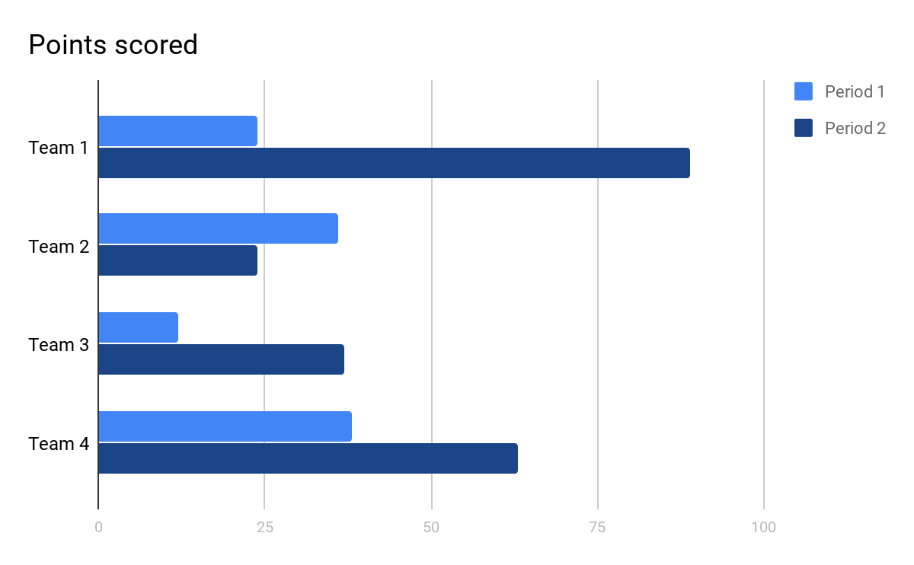

**A bar chart or bar graph is a chart or graph that presents** [**categorical data**](https://en.wikipedia.org/wiki/Categorical_variable) **with** [**rectangular**](https://en.wikipedia.org/wiki/Rectangle) **bars with** [**heights**](https://en.wikipedia.org/wiki/Height) **or** [**lengths**](https://en.wikipedia.org/wiki/Length)**proportional to the values that they represent. The bars can be plotted vertically or horizontally. A vertical bar chart is sometimes called a line graph.**

**A bar graph shows comparisons among** [**discrete**](https://en.wikipedia.org/wiki/Discrete_variable)[**categories**](https://en.wikipedia.org/wiki/Categorical_variable)**. One axis of the chart shows the specific categories being compared, and the other axis represents a measured value.**

# User Manual (How To Use Our Project)

## Run it from command prompt

Write cd then choose the folder path then click enter , then write python then the project name (Statistics.py)

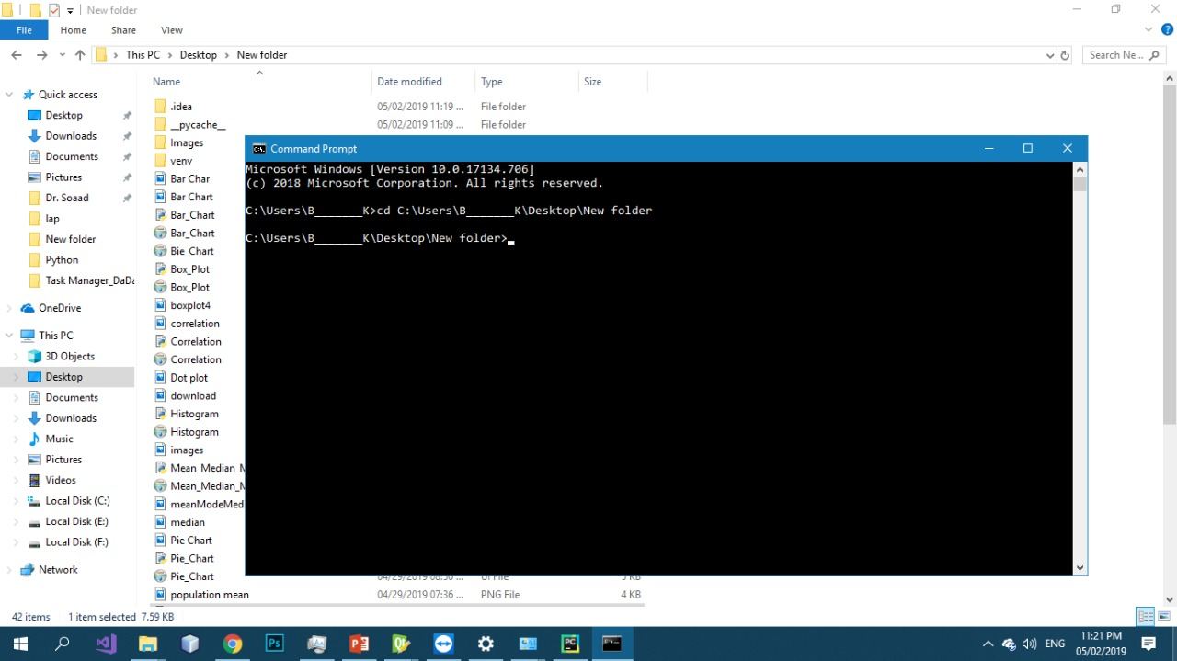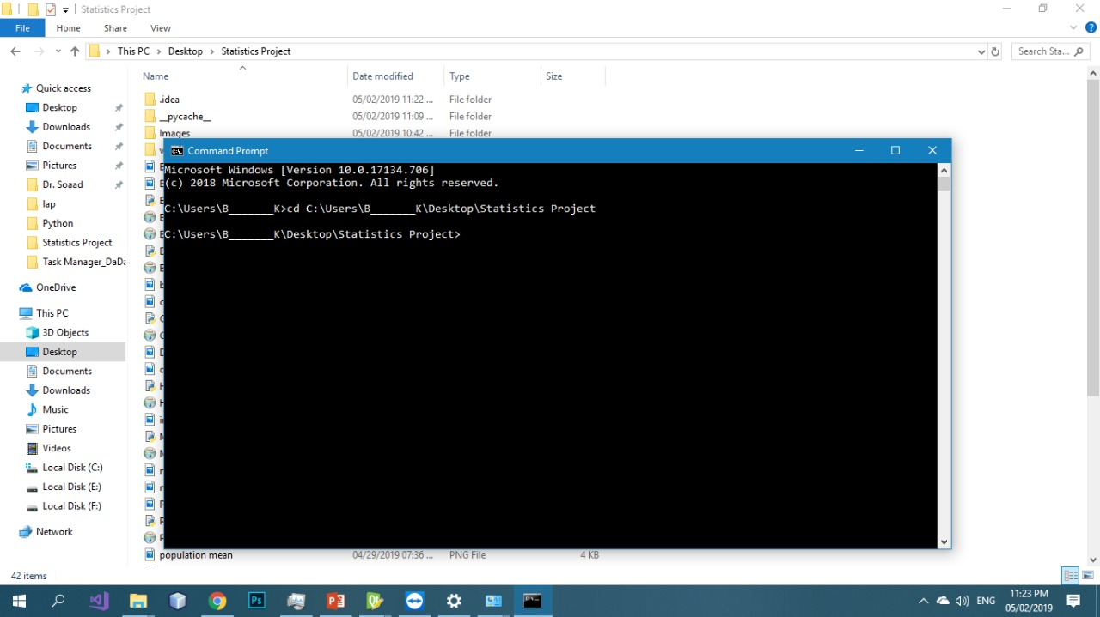

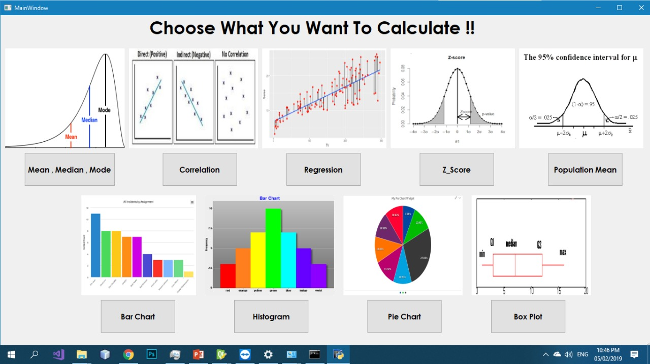

## Choose what you want to calculate

Ex: write the value in the text box then click add it will appear in the larger text box then press calculate